TCP Based key value store

An in-memory key value store using java socket programming

­Problem Statement:

Abstract

A key-value database, or key-value store, is a data storage paradigm designed for storing, retrieving, and managing [associative arrays](https://en.wikipedia.org/wiki/Associative_array), a [data structure](https://en.wikipedia.org/wiki/Data_structure) more commonly known today as a dictionary or [hash table](https://en.wikipedia.org/wiki/Hash_table). Some key value stores maintain data in-memory, while others use solid-state drives or rotating disks. Among the above mentioned two, in-memory key value store provides fast and efficient processing. In this document, we present a java based key value store for storing and retrieving data.

Amartya Choudhury

BCSE -IV

Roll-001610501026

amartyachowdhury98@gmail.com

Internet Technology Laboratory

Implement a TCP-based key-value store. The server implements the key-value store and clients make use of it. The server must accept clients’ connections and serve their requests for ‘get’ and ‘put’ key value pairs. All key-value pairs should be stored by the server only in memory. Keys and values are strings.The client accepts a variable no of command line arguments where the first argument is the serverhostname followed by port no. It should be followed by any sequence of “get <key>” and/or “put <key><value>”.

./client 192.168.124.5 5555 put city Kolkata put country India get country get city get Institute

India

Kolkata

<blank>

The server should be running on a TCP port. The server should support multiple clients and maintain their key-value stores separately. Implement authorization so that only few clients having the role “manager” can access other’s key-value

stores. A user is assigned the “guest” role by default. The server can upgrade a “guest” user to a “manager” user.

Introduction:

Businesses must ensure that their data is durable by keeping it safe on disk. However, in-memory databases are also useful in some instances, such as the following:

* **High-speed caching:** To remove read workloads from the database of record, to reduce the cost of hardware and software licenses, and to prevent distributed denial-of-service (DDoS) attacks from affecting a live system.
* **Transient data holding:** Data that isn’t very important and that has a known lifespan. A typical web application’s details on users’ sessions are good examples.
* **Analysis before storage:** For example, large memory systems are used by scientists to analyze stellar observations. Most of the time, telescopes are looking at a blank bit of sky — no need to store that data! Scientists analyze the data quickly in memory, and store only what’s useful.

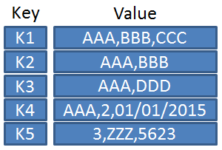

Fig 1: A table showing different formatted data values associated with different keys

Because of their uncomplicated nature, many in-memory databases are also key-value stores. In-memory use also lends itself to high-speed applications. Retrieving a record using its unique key is the quickest way to retrieve data, so key-value stores and in-memory databases are a natural fit.

* Redis began as an in-memory database. Indeed, Redis can still be used in this way. Redis does operate as a single process, though, so you need to run multiple instances of Redis on each server in order to get full utilization of its resources.
* Hazelcast is an in-memory NoSQL database that replicates its data to other Hazelcast nodes in the cluster. It is an open-source product, but it’s also offers a commercial product (Hazelcast Enterprise) with more features. Hazelcast is used within the commercial version of the OrientDB triple store. OrientDB uses Hazelcast in order to provide high availability. Hazelcast effectively provides replication of OrientDB’s data structures

Design:

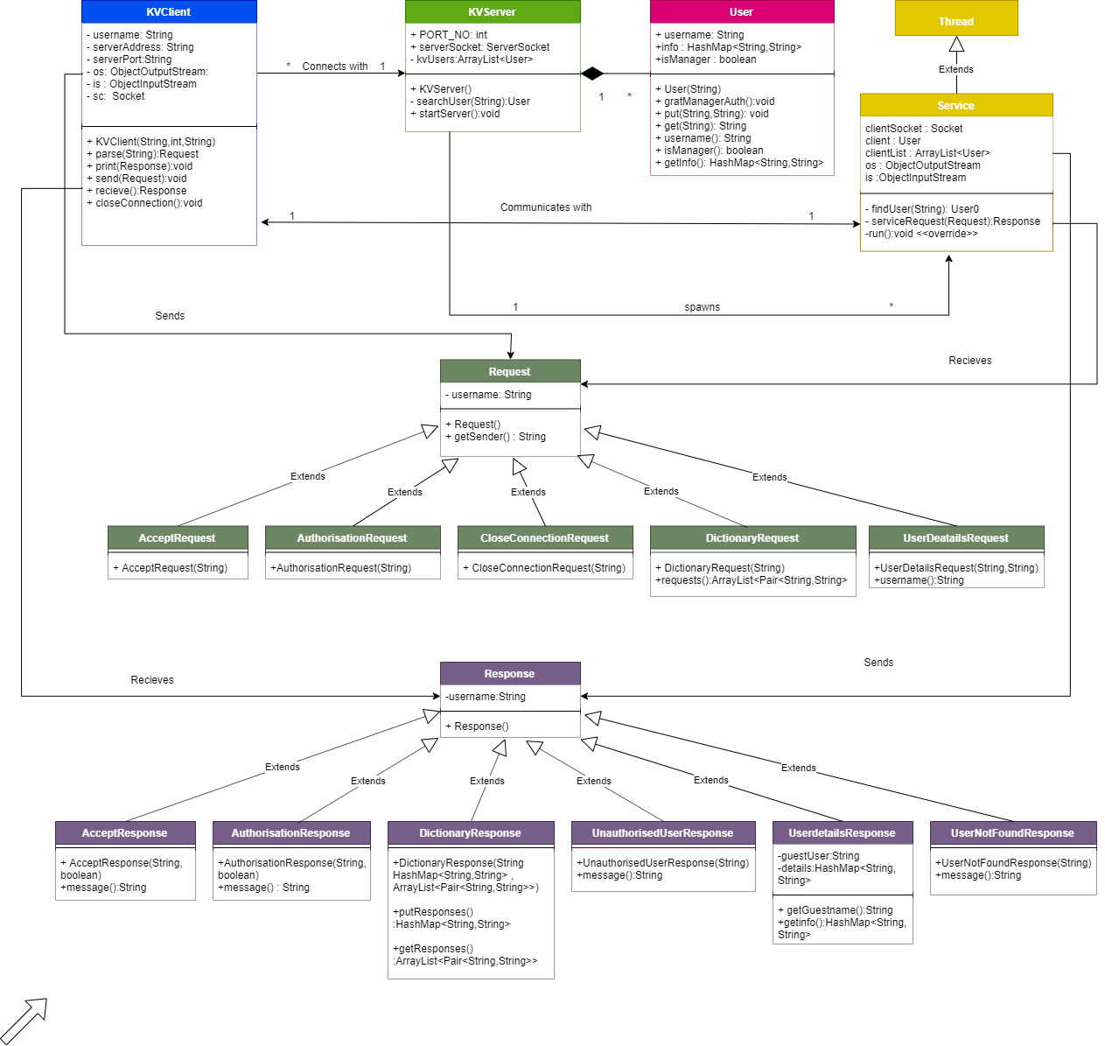

Fig 2 :Class Diagram of Key Value store

1. The Key Value Server listens on port number 8000 for incoming connections for clients
2. It maintains an in-memory dynamic list of User objects .
3. A User has a userId , his / her own dictionary , and whether he / she is a manager or not .
4. A key value client knows the socket address of the server , it connects to it
5. The server detects an incoming connection and spawns a new service thread to serve the client
6. The client and the service communicate over a TCP connection.The client sends requests , the server sends back responses.
7. Requests are of the following types and are handled in a separate manner by the service thread –

* AcceptRequest(Client requests the server to accept its connection)
* AuthorisationRequest(Client requests server to promote to manager Role)
* UserDetailsRequest(Client requests dictionary of another user , invalid request if client is not a manager)
* DictionaryRequest(Client sends a number of put / get commands to modify / read his own dictionary)
* CloseConnectionRequest(Client Server to close the connection)

1. The service threads sends back “Responses” which are of the following types –

* AcceptResponse(Different responses if the client is new , or an existing client wanting to reconnect to his / her store)
* AuthorisationResponse( Conveys , if not already a manger that the request was granted )
* DictionaryResponse(Returns the values for the keys in the request , if they exist)
* UnauthorisedUserResponse(Sent , if a user who is not a manager asks for dictionary of another User)
* UserDetailsResponse(Dictionary of another user , sent to a manager)
* UserNotFoundResponse(Sent to a manager if the user whose details he/she requests doesn’t exist)

Code Snippets:

* client execution:

|  |
| --- |
| **public** **static** **void** **main**(String args[]){  //fetch server credentials  String serverInetAddress = args[**0**];  **int** serverPort =Integer.parseInt(args[**1**]);  //fetch client username  String clientUsername = args[**2**];    KVClient client =**null**;    //create new client  **try**{  client = **new** KVClient(serverInetAddress,serverPort,clientUsername);  }  **catch**(UsernameExistsException e){  e.printStackTrace();  **return** ;  }  Scanner sc = **new** Scanner(System.in);  //until connection closed  **for**(;;){  String input = sc.nextLine();  **if**(input.equals("Exit")){  client.closeConnection();  **break**;  }  //parse input  Request rq = **null**;  **try**{  rq = client.parse(input);    }  **catch**(InvalidInputException e){  e.printStackTrace();  }  **catch**(NoSuchElementException e){  e.printStackTrace();  }  //send request  client.send(rq);  //print response  client.print(client.recieve());  System.out.println("------------------------------------------------------");  }  } |

-service Thread execution:

|  |
| --- |
| **public** **void** **run**(){  **for**(;;){  **try**{  Request rq = (Request)is.readObject();  **if**(rq **instanceof** CloseConnectionRequest){  clientSocket.close();  System.out.println("Closing Session with " + client.username());  **break**;  }  Response rs = serviceRequest(rq);  os.writeObject(rs);  }  **catch**(IOException e){  e.printStackTrace();  }  **catch**(ClassNotFoundException e){  e.printStackTrace();  }  System.out.println("------------------------------------------------------");  }  } |

Output:

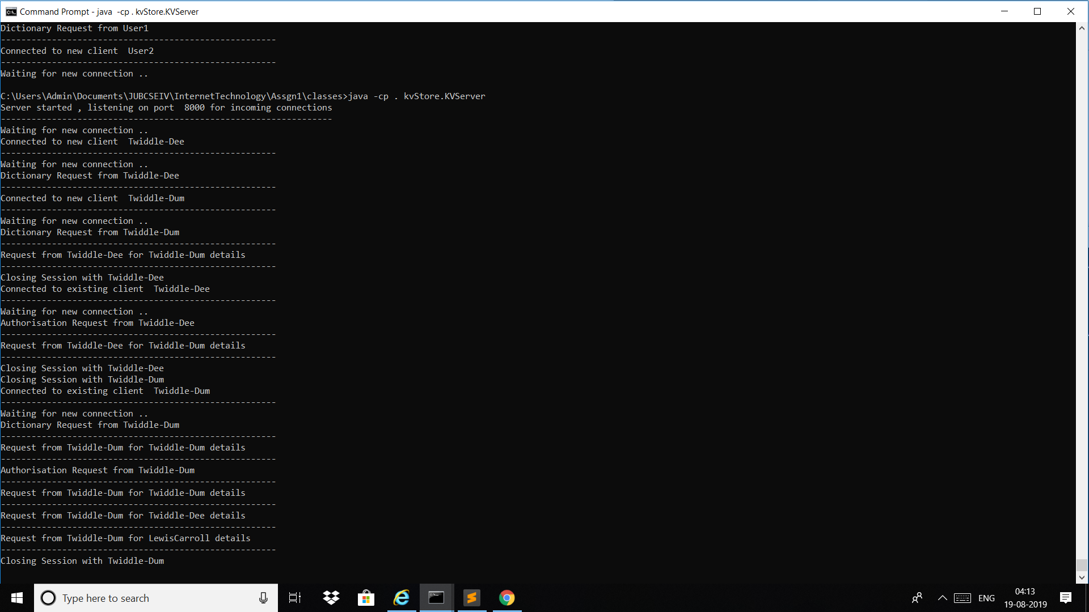

Fig 3: KVServer

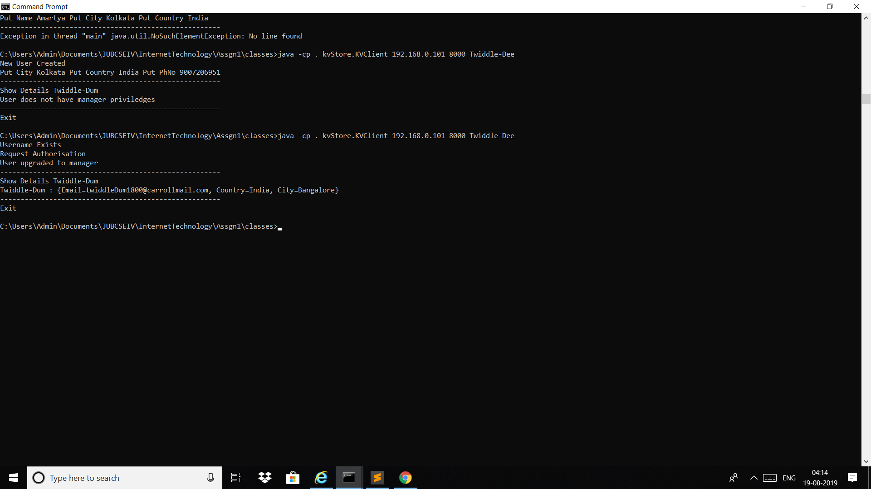

Fig 4: Client 1

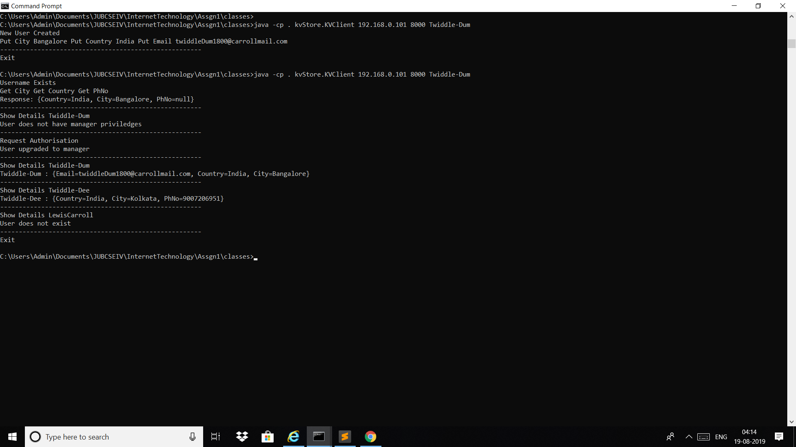

Fig 5: Client 2

References:

1. <https://en.wikipedia.org/wiki/Key-value_database>
2. <https://www.dummies.com/programming/big-data/nosql/in-memory-key-value-stores-in-nosql-databases/>